**PRACTICUM 10**

**FURTHER TOPIC (NETWORK COMMUNICATION)**

NIM : L200194009

Name : Nadia Zerlinda

Assistant Name : Ganno Tribuana Kurniaji

Practicum Date : 2

1. Activity 1

This is screenshot after runing program

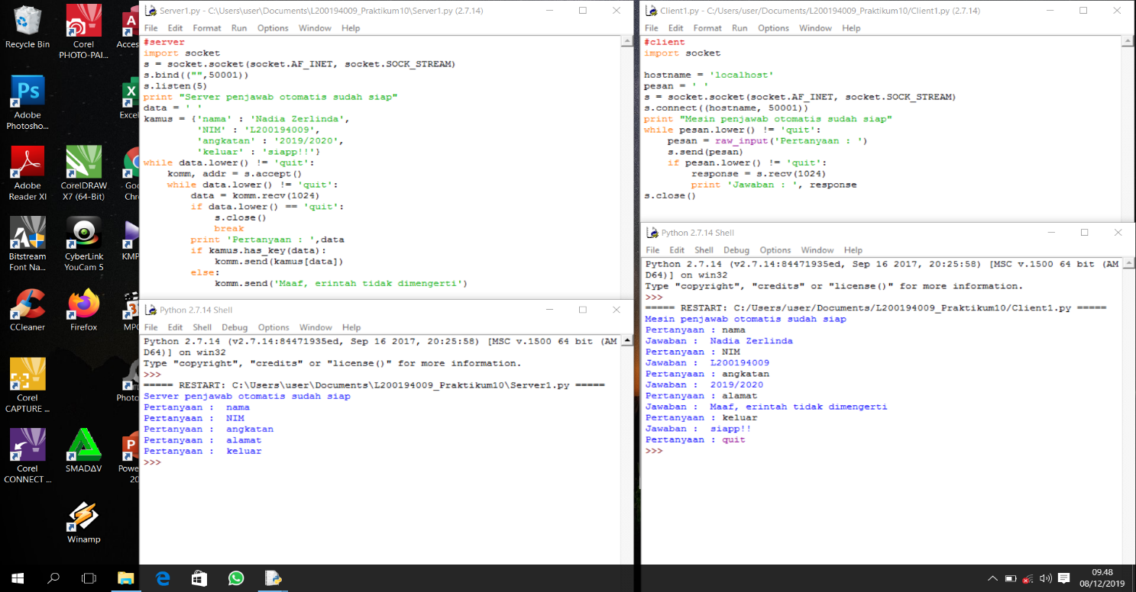

1. Activity 2

This is screenshot after running program

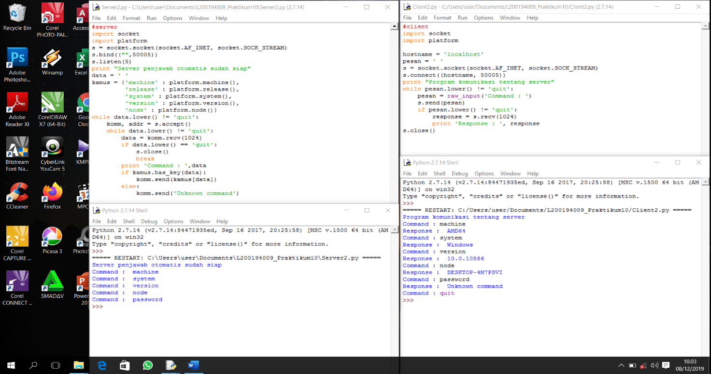

1. Activity 3

This is screenshot after running program

